Center Foot Assembly

Vex Omni Wheels for Mr. Baddeley MKIII

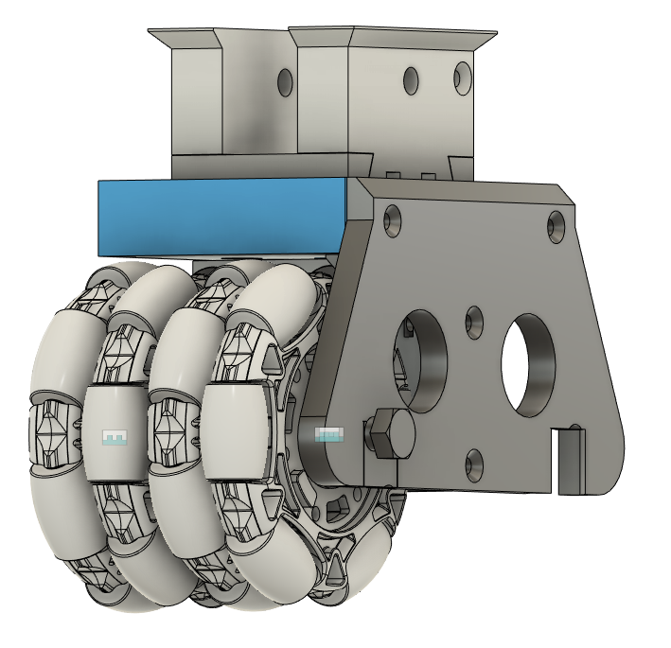

Vex Omni Wheel Assembly Instructions

These instructions detail how to assemble the center foot using the VEX robotics 4” Omni Wheels. For assembly, the following pieces are required to be printed. These pieces are modified versions of the MKIII center foot to fit the larger VEX Omni Wheels.

# Printed Parts

|  |  |
| --- | --- |
| Filename | Image |
| VexFrameTop.stl |  |
| VexFrameCenter.stl |  |
| VexFrameSidex2.stl Print 2 |  |
| VexRodx4.stl Print 4 |  |
| VexSpacer4mm.stl |  |
| VexSpacer5mm.stl Print 4 |  |

# Required Hardware

|  |  |  |  |  |
| --- | --- | --- | --- | --- |
| P/N | Description | Qty | Order Link | Notes |
| 217-6194 | 4" Omni-Directional Wheel v2 | 4 | https://www.vexrobotics.com/omni-wheels.html |  |
| 217-3234 | 1.125" Bearing Pilot Plastic VersaHub (1/4" Wide, w/ Plate Sprocket Mount) | 2 | <https://www.vexrobotics.com/versahubs.html> | Used to space the two omniwheels apart and lock the orientation. |
| 217-2732 | 0.375" ID x 1.125" OD x 0.313" WD (Flanged Bearing) | 8 | https://www.vexrobotics.com/bearings.html | 4 Minimum. 8 required if using bearings in the center for each wheel |
|  | 3/8" x 4.5" hex bolt | 2 | Available at local hardware store | Axle |
|  | 3/8" hex nut | 2 | Available at local hardware store | Nyloc nuts optional |
|  | 3/8" washer | 4 | Available at local hardware store |  |
|  | M4 square nuts |  | <https://www.amazon.ca/gp/product/B07SDL3WJS/ref=ppx_yo_dt_b_asin_title_o05_s00?ie=UTF8&psc=1> | |
|  | Misc M4 flat head (countersunk) screws |  | <https://www.amazon.ca/gp/product/B071JY2BD3/ref=ppx_yo_dt_b_asin_title_o05_s00?ie=UTF8&psc=1> | Various Lengths |

# Assembly

1. Print all frame parts and spacers.
2. Install square nuts into center frame opening.

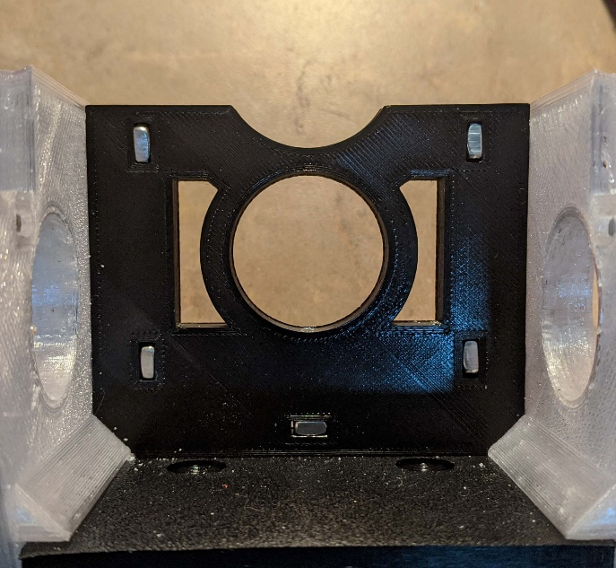

1. 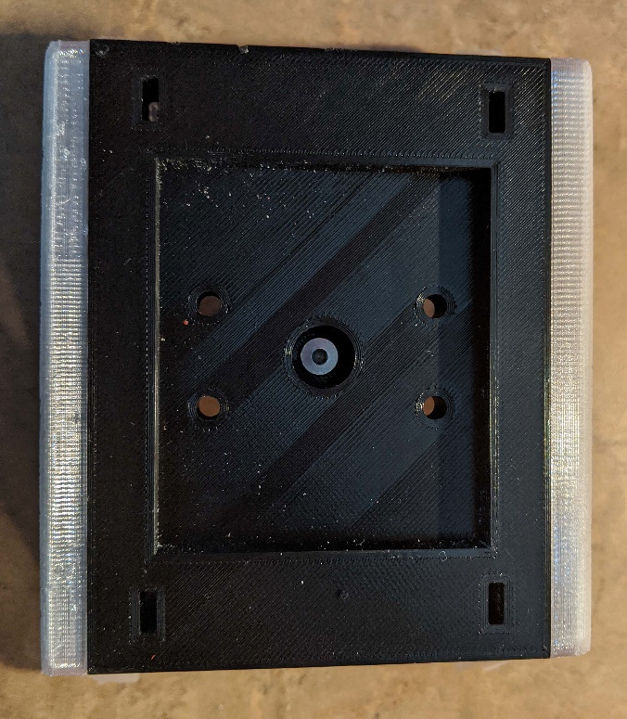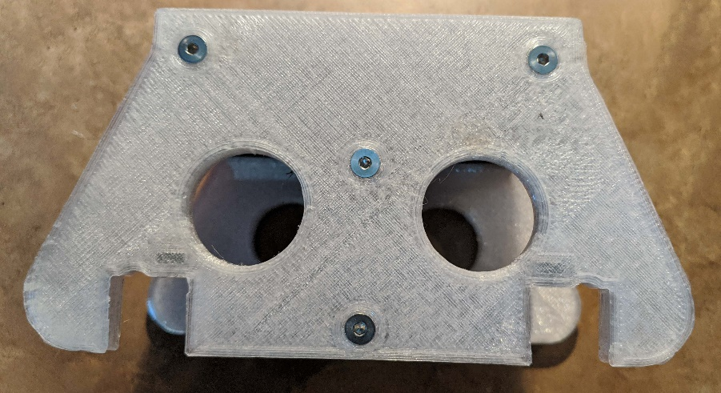Attach side frames and top to the center frame using M4 flat head screws.
2. Next Assemble the Omni Frame wheel assemblies.
3. Install a bearing to each side of a single Omni Wheel.

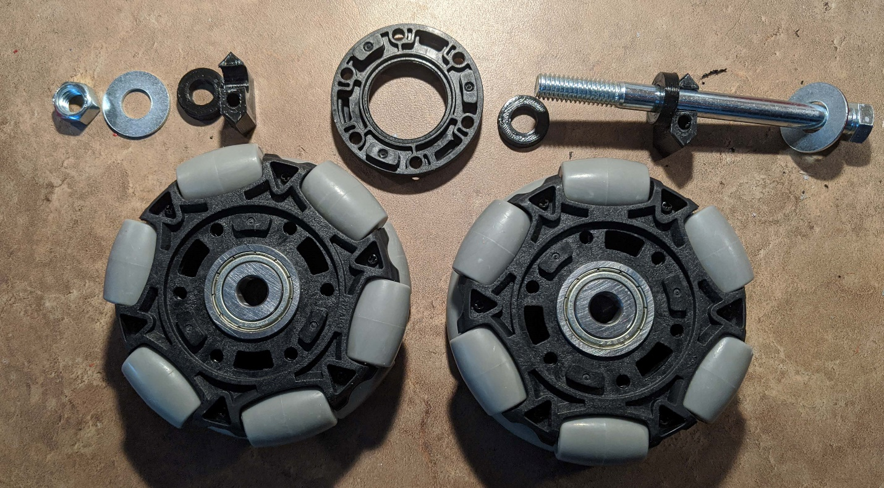

1. Place a washer on the bolt, then a Rod holder (VexRodx4.stl), and a 5mm spacer. There is a small taper on the spacer, this should be towards the bearing.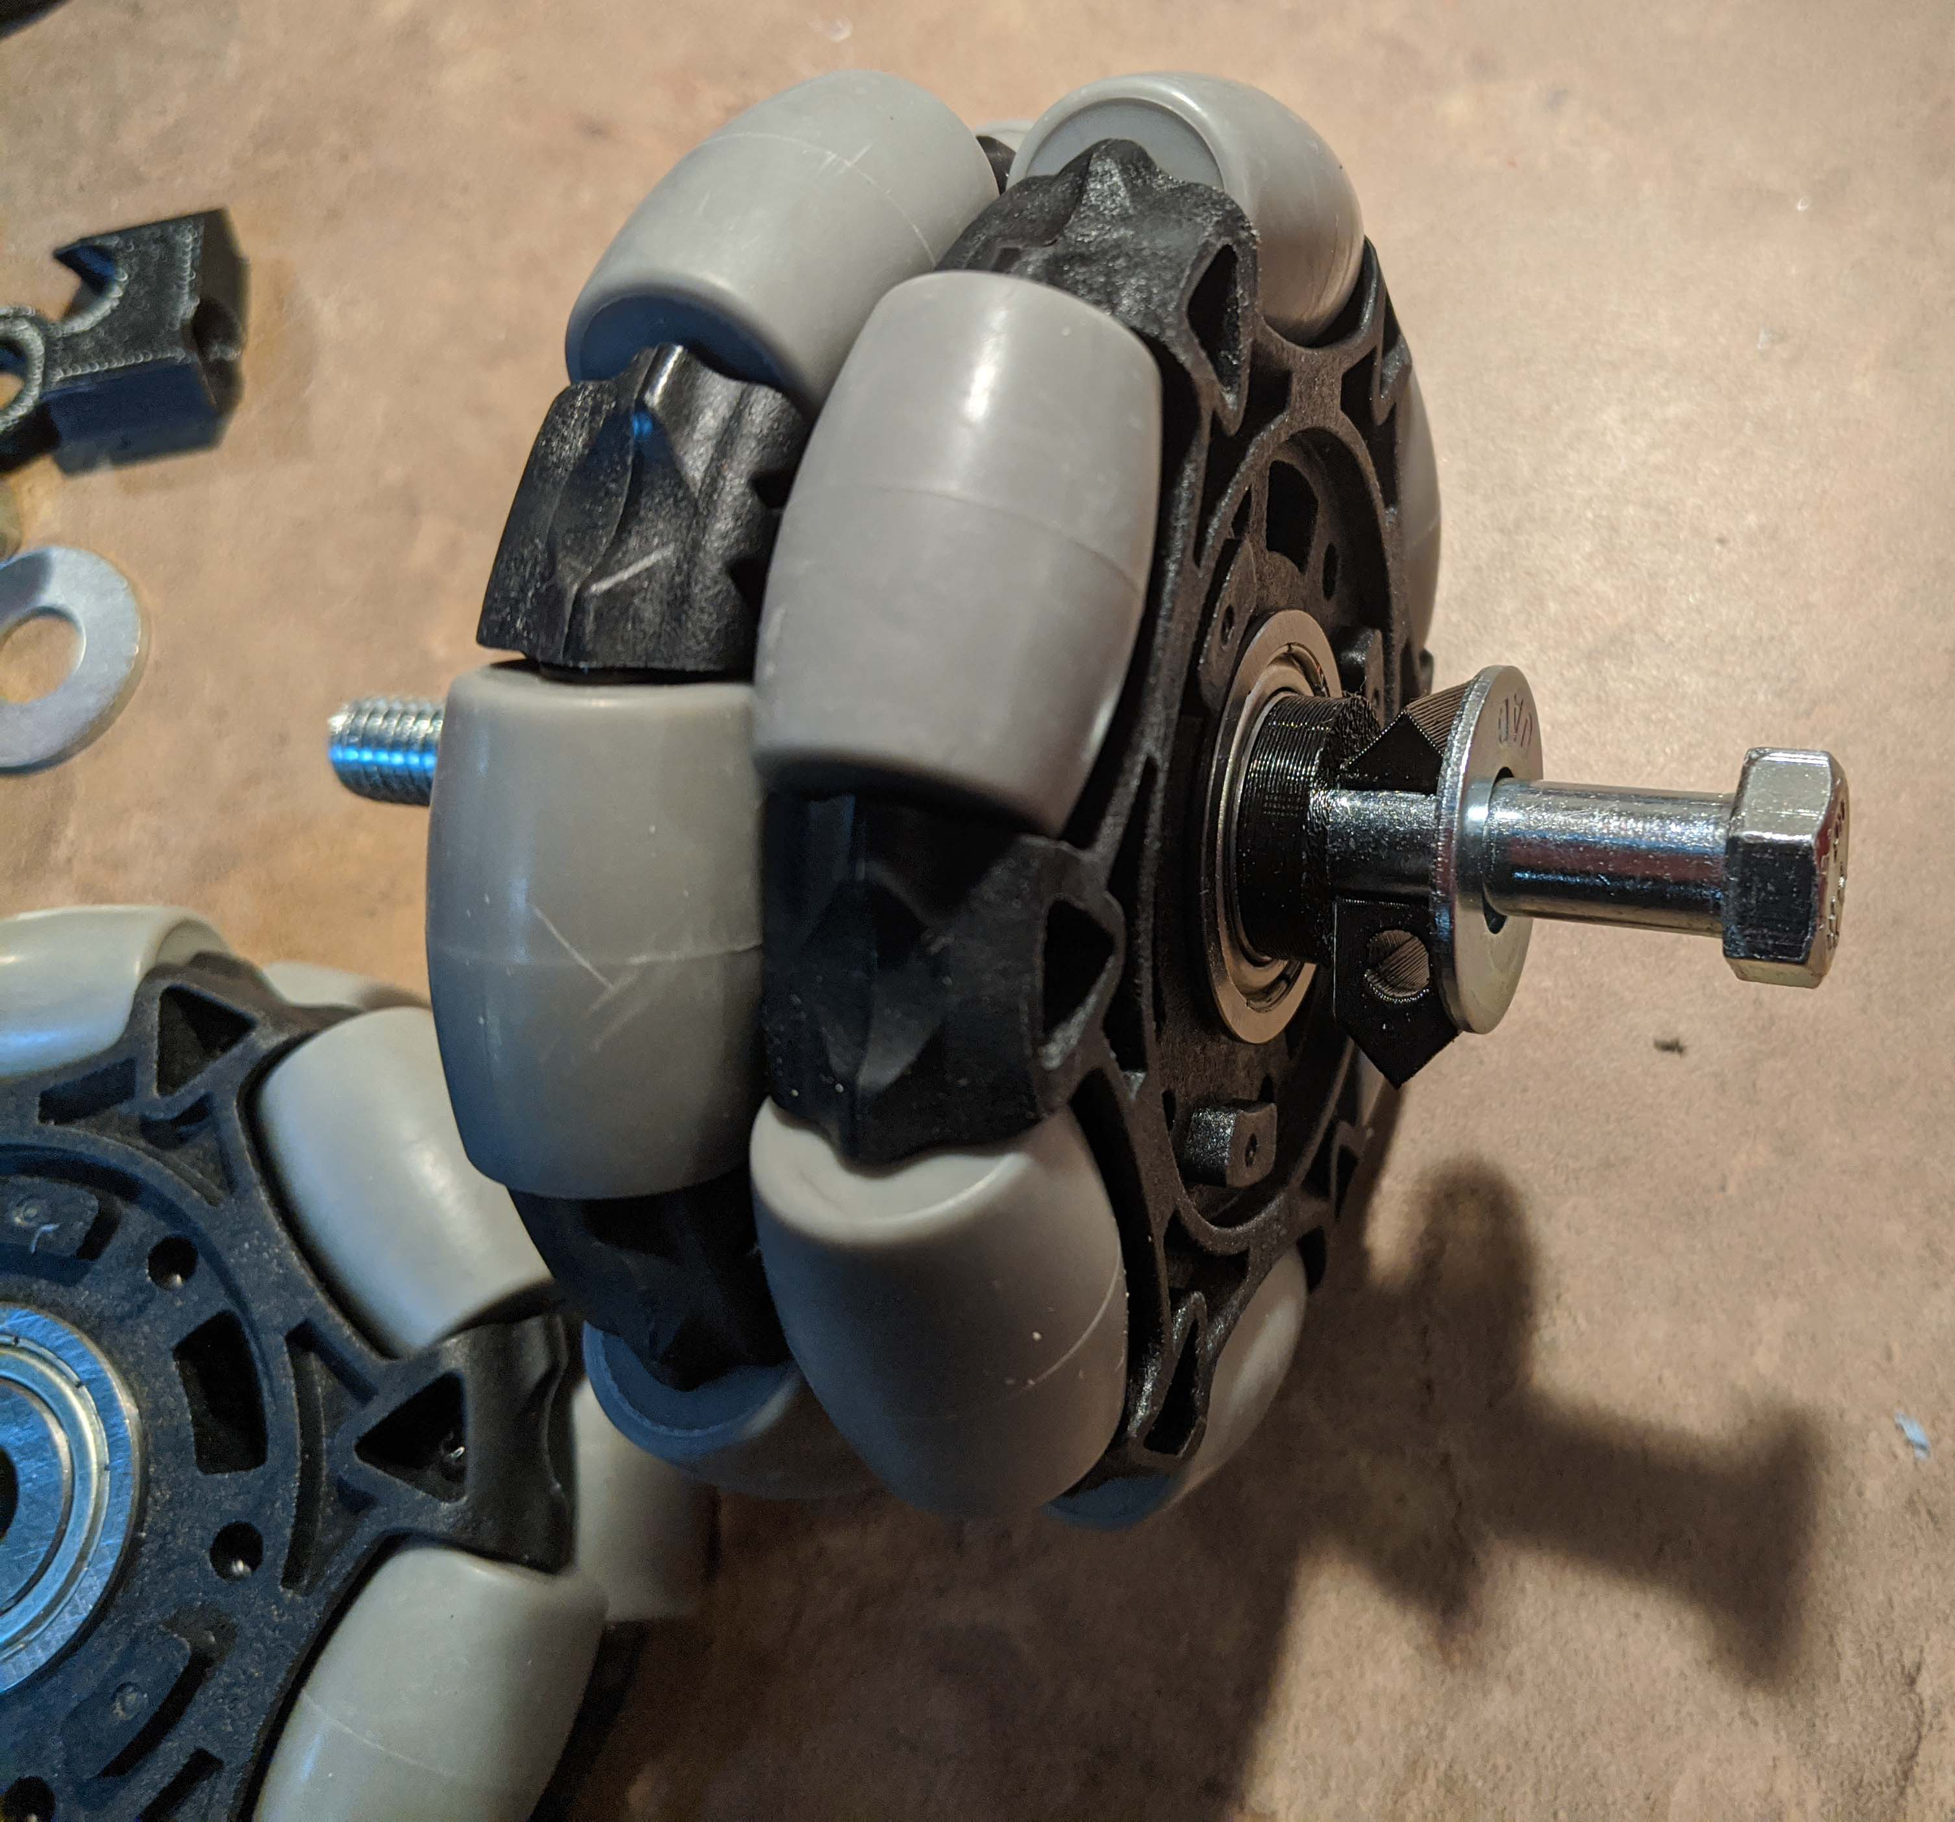
2. An Omni wheel is next and the 4mm spacer with the Versa Hub next. Finally, complete the assembly with another Omni Wheel, 5mm Spacer, Rod holder, Washer and Nut.

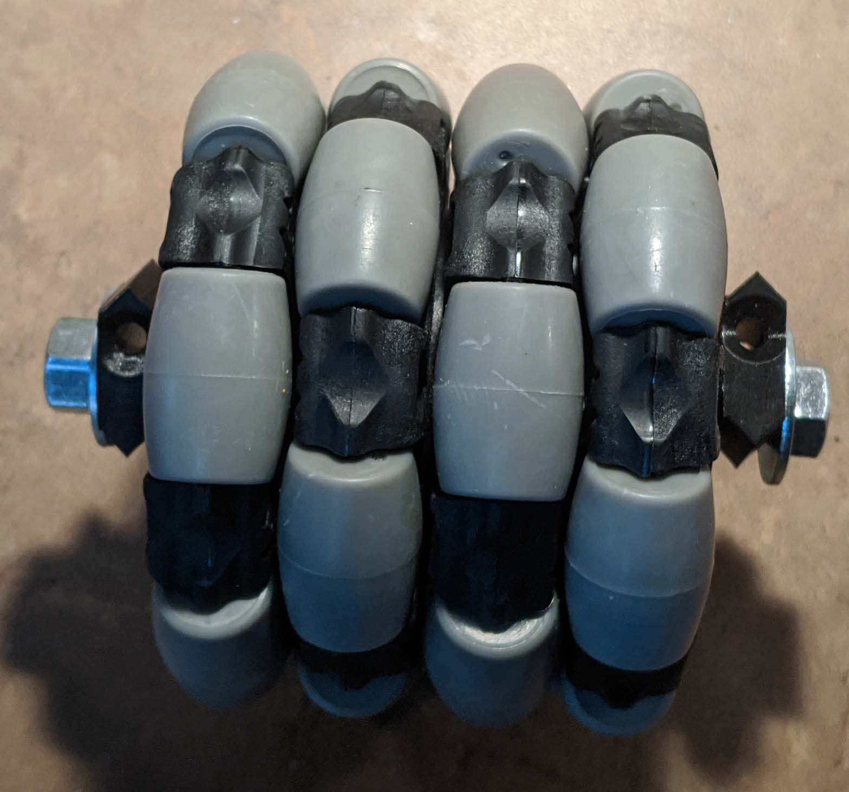

The Versa Hub is used to lock the two wheel in the proper orientation. The 4mm spacer between the two assemblies insures enough space between the wheels such that they don’t rub together. The V2 wheels will run slightly when using the ¼” spacer alone.

1. Bolt the frame assembly to the ankle using the M4 flat Screws.

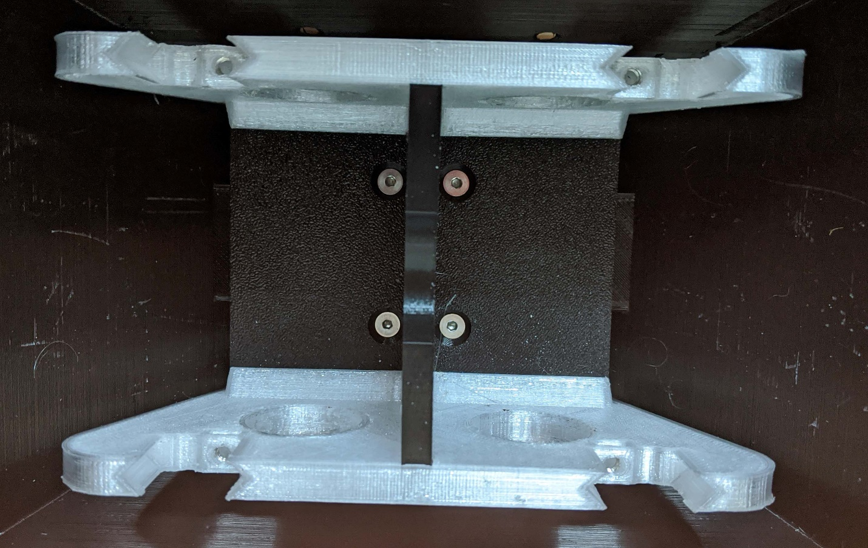

The skin if first slid over the ankle and the frame will bolt in to hold it all together. If the skin is not tight to the ankle, some foam rubber can be installed between the frame and the skin to hold it all tight. The 8mm rod for the ankle and ankle must be installed before the frame and skin is bolted together.

1. The omni wheel assemblies can now be slotted into the frame and secured with M4 Flat bolts. If the assembly is too tight, or too loose, then adjust using different spacer thicknesses.

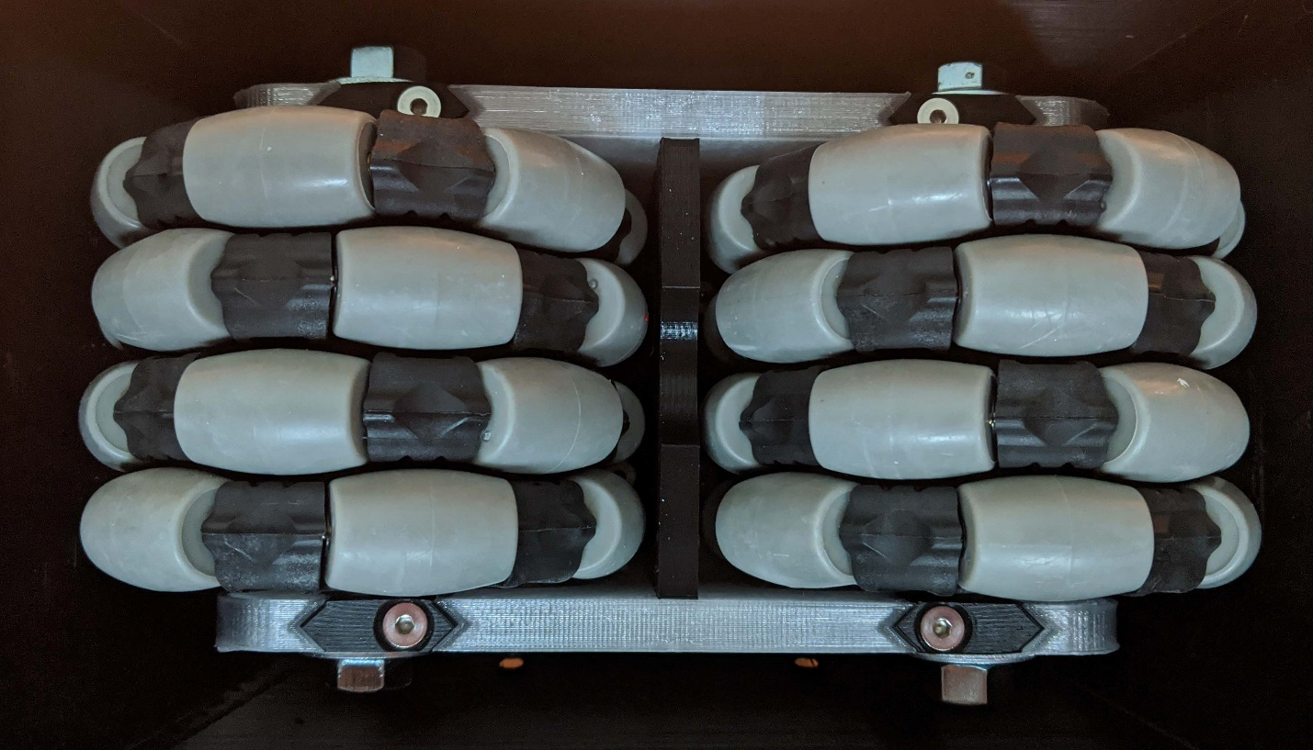

The 3/8” bolts can now be snugged up to ensure a tight, no slop assembly.

That’s it.